

Our School Community Newsletter

WARBY NEWS

Deans Road, Airds NSW 2560

Ph.: 46258140 Fax: 46281637

Email: johnwarby-p.school@det.nsw.edu.au

Webpage: [www.johnwarby-p.schools.nsw.edu.au](http://www.johnwarby-p.schools.nsw.edu.au)

**1st March 2016 Week 6 Term 1**

**Calendar**

**Wednesday 2nd March**

* Whole School Assembly 2.15pm

**Thursday 3rd March**

* P & C AGM

9.30am

**Wednesday 9th March**

* Harmony Day Performance 1.30pm

**Friday 18th March**

* Stage 1 Symbio Zoo Excursion

Next week on Tuesday 8th March we have Sue Larkey, well known for her work with children with Autism, visiting our school to work with our staff on best catering for the needs of the children with Autism who are in our mainstream classrooms. As part of this visit we have made some time available for Sue to provide a brief workshop to parents and carers. This parent session will run from 2.40pm to 3.10pm. Students of parents who are attending this session will be supervised in the hall. A note will be going home shortly.

As a school we are currently in the process of reviewing our School Plan for 2016. If any parents or carers would like to comment on the directions of the school or make suggestions for possible improvements please feel free to contact the Principal as your feedback is very valuable when setting our school priorities.

Attendance

Thank you to everyone who has taken the effort to get their child to school each day. It is concerning that a number of our families are organising holidays during school terms. It is important that students attend school everyday so that they can maximise their learning opportunities and develop strong and consistent relationships with their peers. Please organise family holidays during school holiday periods.

Receiving Newsletters

If you would like to receive the school newsletter by email please contact the school office with your email address. This will help to reduce the school’s impact on the environment.

Operating Hours

A reminder to everybody that the school’s operating hours are 8:30am to 3:00pm. No supervision for students is organised outside of these hours. I would appreciate parents and carers not letting their children come to school before 8:30am. While many teachers get to school before 8:30am they do so to finalise their lesson preparation for the day and are not in a position to be supervising early arrivers.

**Updates from 1T**

Change your words, Change your mindset

We are learning to change our fixed mindset to a growth mindset. This means that if we persist at our learning, take risks, ask questions and bounce back when things go wrong we can strive to achieve great success. We are learning to turn negative comments into positives!

MEDALS & MISSIONS

In 1/2T we love writing! This year we have our very own missions to achieve when we write. When we achieve a mission we put a star on it and we are awarded a medal and certificate. The certificate gives us feedback about what we did well at in our writing and what the next step is. Our parents can even write a comment on the certificate and it is displayed in our room. How cool is that? Keep posted on the JWPS website for updates on our medals and missions.

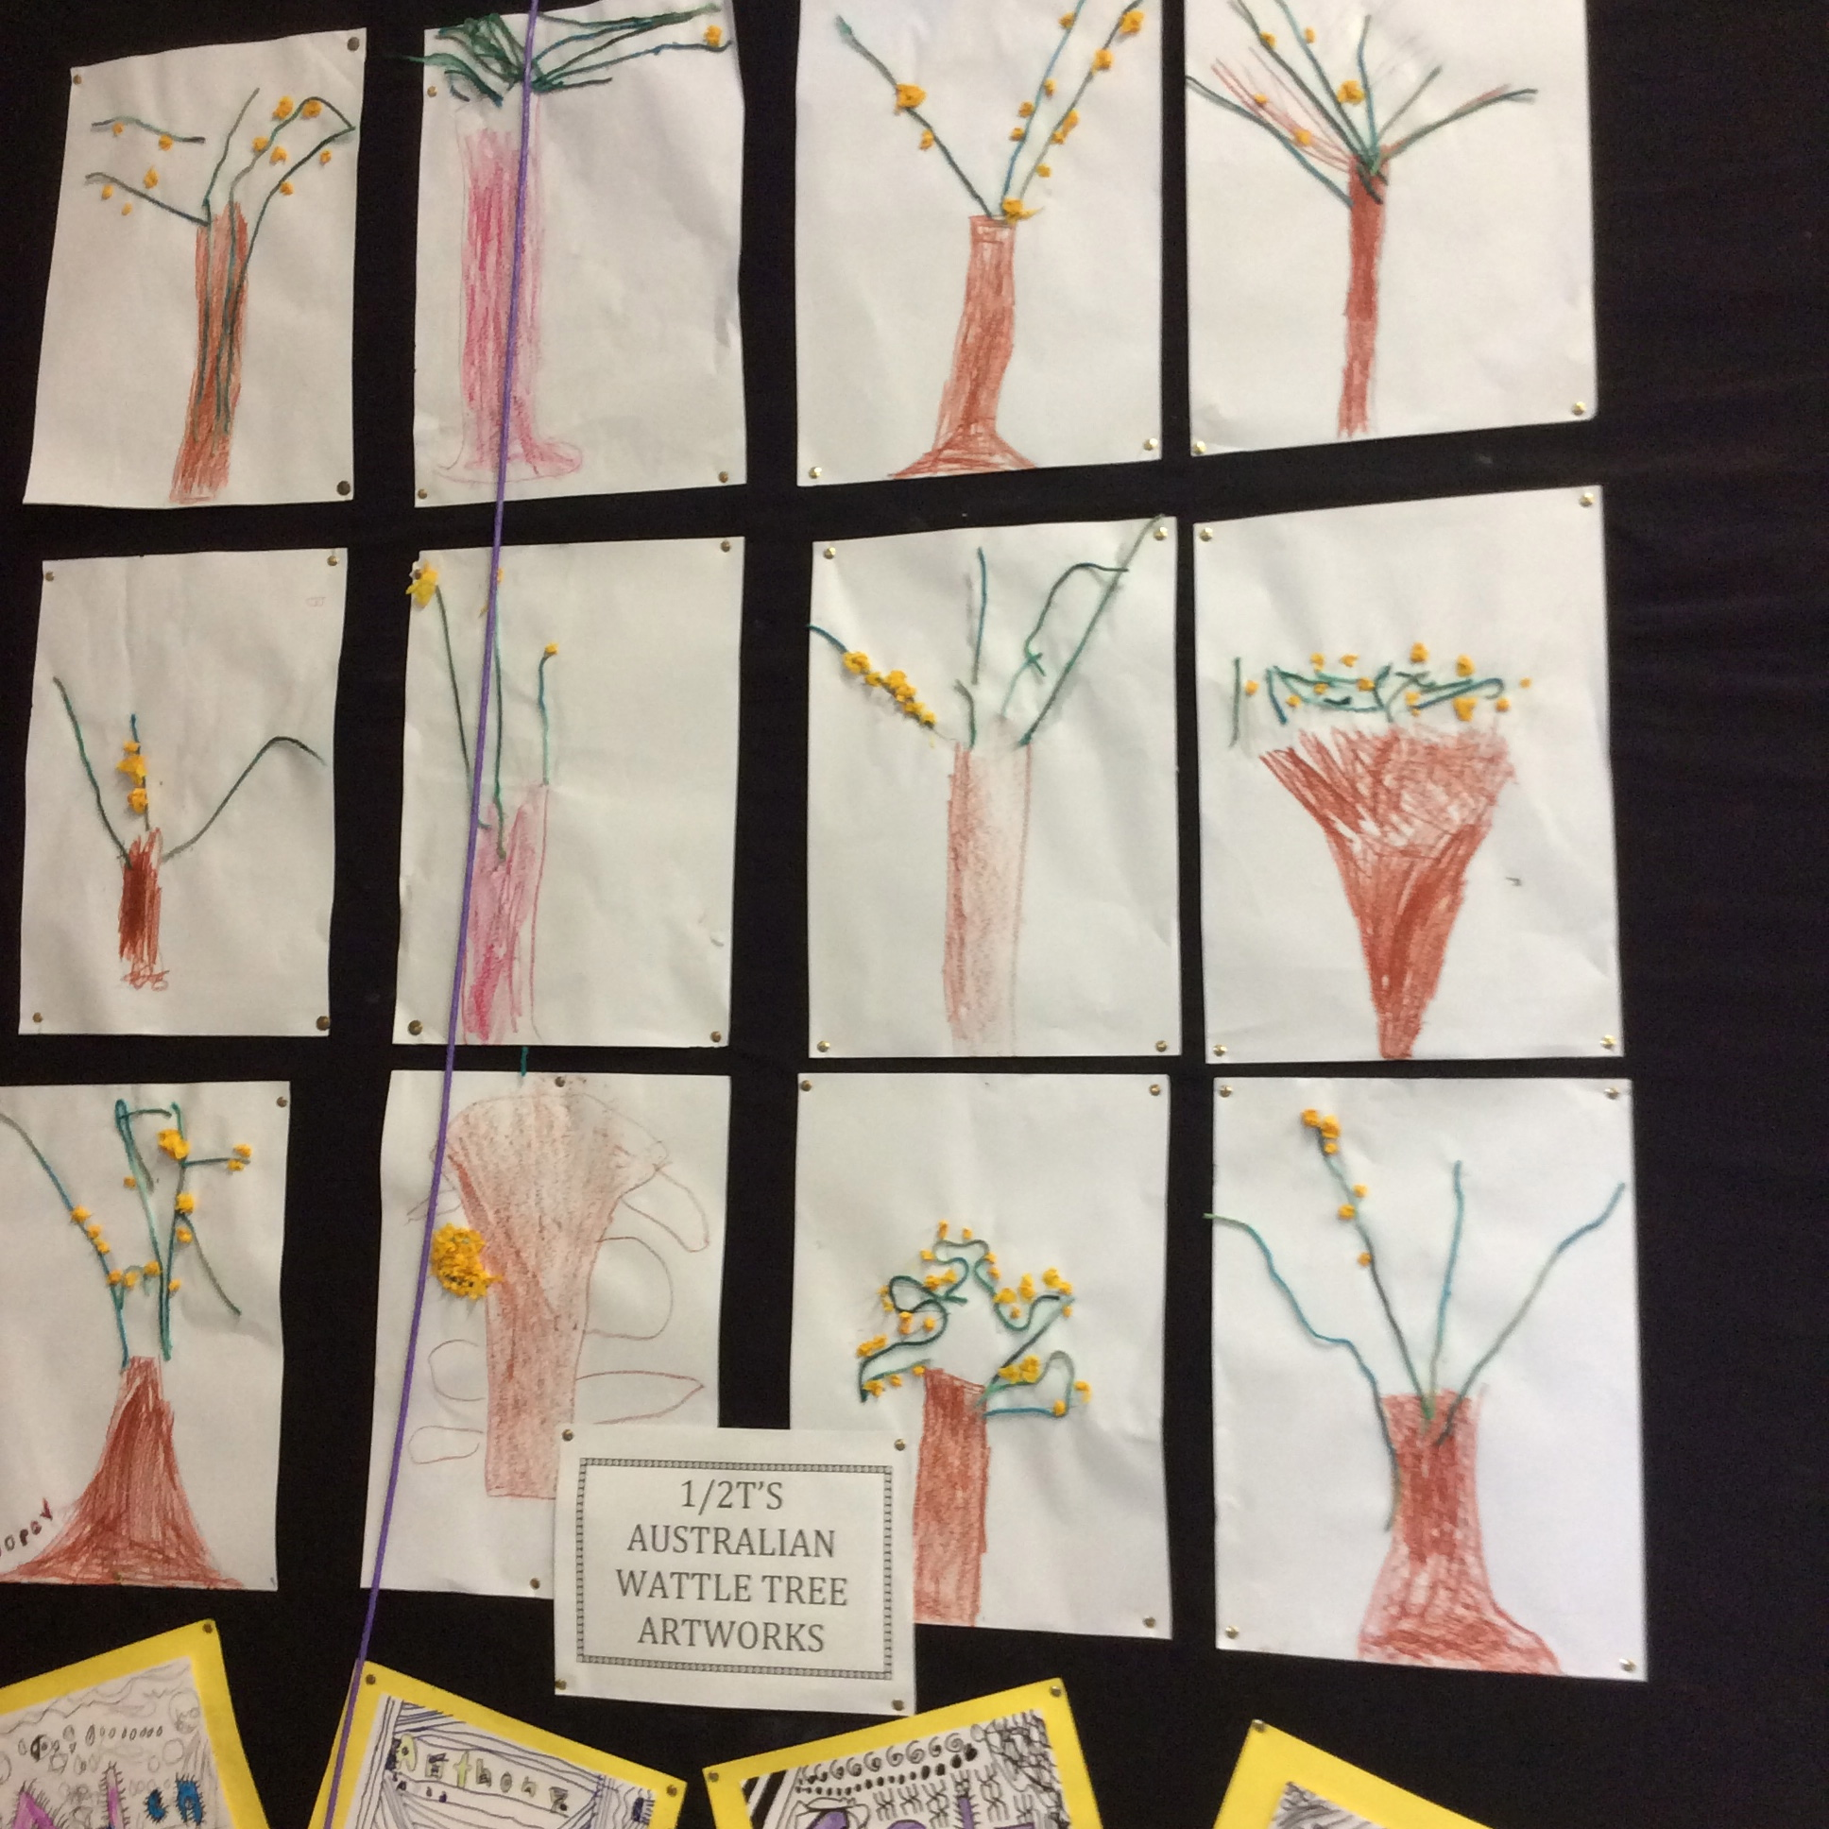

Mrs Thompson &1/2T

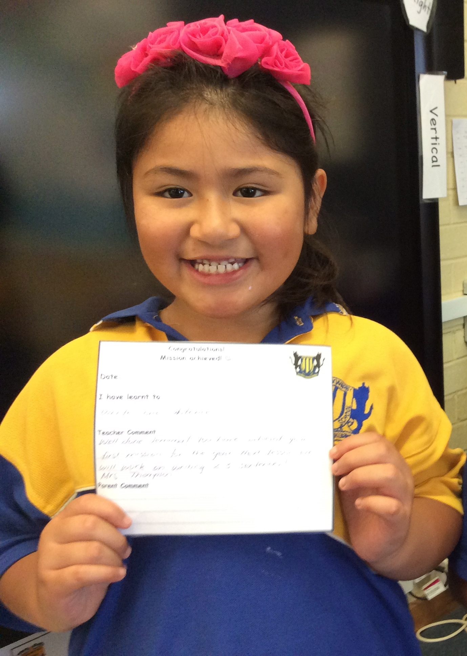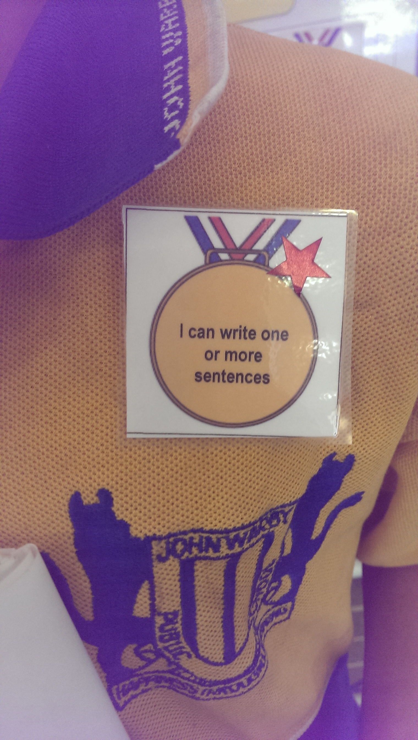

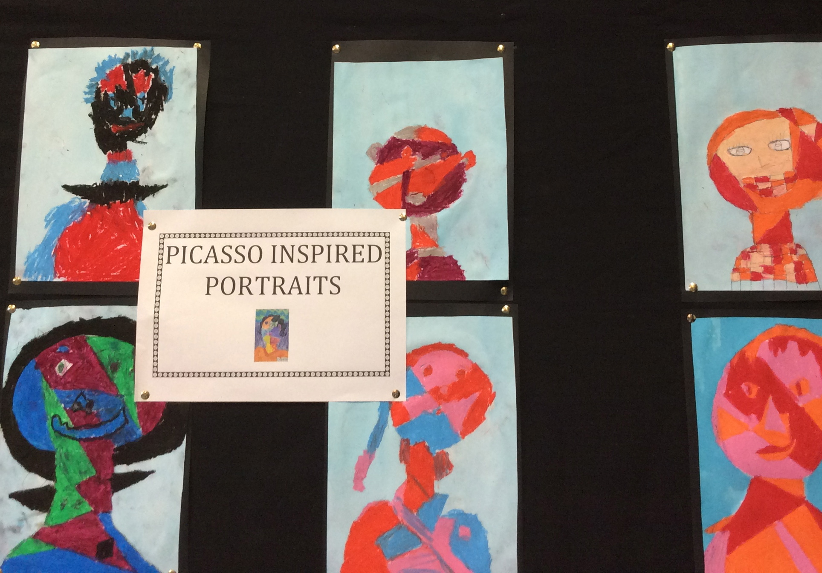

**6L**

Welcome to 2016!

We’ve started the year with a bang and are currently forging ahead without persuasive writing, reading groups and maths.

Together with Mr Lord we have been busy organising our assembly item which will be presented in week 6. It’s a collection of short stories we’ve been working on about a book we’ve been reading called the BFG. We’ve used a website called Storybird to design some picture books about the nasty giants in the book. It’s a lot of fun using the artwork to tell the story.

We’re currently hanging out in a spare classroom opposite the pre-school. We’ll be back in our regular classroom upstairs as soon as one of our classmates recovers from her broken leg! Please drop in anytime and check out some of the work we’ve been doing.

Mr Lord & 5/6L

**Library News**

Library Borrowing

All classes visit the library once a week for a library lesson and borrowing. Please check your child’s library day each week and encourage your child to bring in a library bag on their library day. Thank you to the many families who encourage and support regular borrowing.

The class library days are as follows:

Monday: 4/5H, 5/6L, K/3R

Tuesday: 3-6S, 1D, KR, 1/2T, 2G

Thursday: 3/4W, 3/4A, 3-6P

Library Helpers Needed

Our library has lots of new books that need covering in contact. If you would like to help with book covering at home please ring the school and leave your name at the office and a bag of books will be sent home to you with your child. You can also pick the books up from the office if you would like. Any help with book covering is greatly appreciated.

Overdue Library Books

Unfortunately there are still a number of library books that have not been returned from last year. Please return all library books as soon as possible as borrowing occurs on a weekly basis. A replacement cost of $5.00 needs to be paid to the office if the book cannot be found.

Thank you,

Mrs Smith - Teacher Librarian

**P & C**

Our Annual General Meeting will be held on Thursday 3rd March at 9.30am. Feel free to join us for a cuppa before at 9.00am. We would love to see some new faces, all are welcome.

**Canteen News**

Our Canteen is now fully stocked and ready. To assist with smooth running could you please make sure that all orders are in by 9.30am.

* Keep your eye out for weekly specials that are sent out on a separate note during the term.
* Sunnyboys are now only available Mondays and Fridays at $1.20 each.



