**Continuous Alarm followed by an Announcement**

**Beeping Alarm followed by an Announcement**

# NSW DEPARTMENT OF EDUCATION AND COMMUNITIES

# WELCOME TO

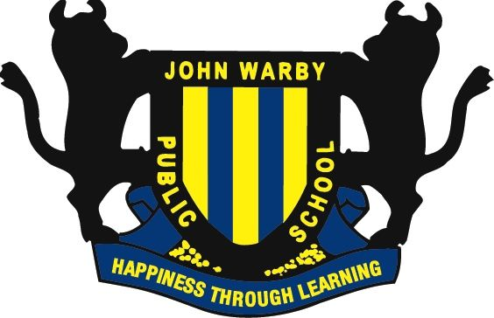

**JOHN WARBY PUBLIC SCHOOL**

# Safety Briefing

The New South Wales Department of Education and Communities is committed to the work health and safety of employees, students, contractors and visitors.

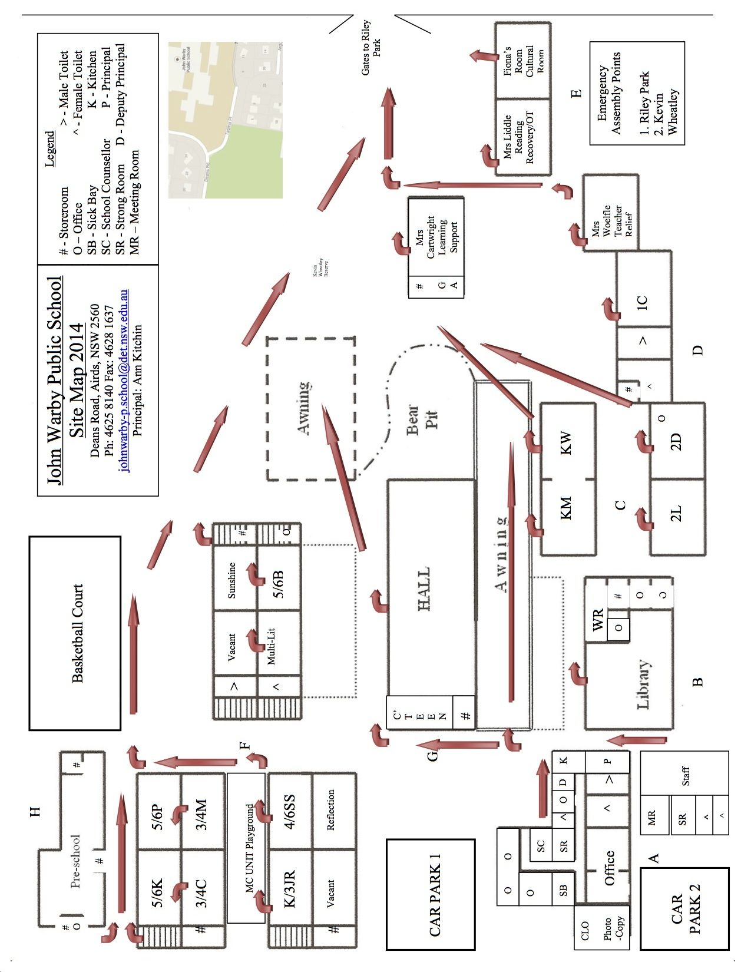

**Emergency Procedures**

In a life threatening emergency

**DIAL 000**

For fire, police and ambulance

In ALL CASES, advise one of the following:

Ann Kitchin – Principal

Sue Harris – SAM

**Exits**

For your safety, make sure you know the location of your nearest exit.

## Evacuation Alarm



**Evacuation Procedures**

When the evacuation alarm sounds:

* Evacuate the building and proceed to the assembly area identified on the map.
* Do not re-enter until advised to do so.

## Lockdown Alarm



**Lockdown Procedures**

When the lockdown alarm sounds:

* Move to the nearest building.
* Remain out of sight and remain quiet.
* Wait for further instructions.

**Smoking**

Smoking is not permitted on DEC premises.

**Alcohol and Illegal Drugs**

Alcohol and illegal drugs are not permitted.

**Weapons**

Weapons, including knives, are not permitted.

**Dangerous Goods and Hazardous Substances**

Visitors and contractors intending to bring dangerous goods on site must declare these at the reception prior to entering the site.

**Reporting Injuries/Hazards**

* All hazards and incidents must be reported to the main office.
* Injuries will be recorded in the *Register* *of Injuries***.**
* First Aid treatment is available on site.

**Local level induction**

Your workplace manager will provide you with a local level induction detailing site safety considerations.

**Contractors**

All Department of Commerce contractors report to the manager or delegate to:

* Indicate the location and duration of the job;
* sign the Visitors log book (if applicable);
* confirm review of asbestos register;
* Advise the status of the job before leaving the site.

All non-Department of Commerce contractors must in addition:

* produce a copy of their safety management plan, including use of personal protective equipment and controls for specific hazards related to the work being undertaken;
* produce public liability insurance documentation before work is commenced.

I have complied with all WHS requirements

Signed: __________________________

Contractor

Date: / /

For your safety and the safety of others, it is a condition of entry to this site that you take a few minutes to read this brochure.

Mandatory site requirements:

* All visitors are required to report to the Administration Office on arrival.
* All visitors are required to observe all speed, parking and vehicular restrictions.
* All visitors are required to obey all safety signs and barricades.
* Violent, threatening or other unacceptable behaviour is not tolerated on NSW Department of Education and Communities premises.